**Microsoft Azure Fundamentals (AZ-900)**

**What is meant by Azure Cloud?**

At its core, **Azure** is a public **cloud** computing platform – with solutions including infrastructure as a Service (**IaaS**), Platform as a Service (**PaaS)**, and Software as a Service (**SaaS**) that can be used for Services such as analytics, virtual computing, storage, networking, and much more.

**What is meant by Microsoft Azure?**

**Microsoft Azure,** commonly referred to as **Azure**, is a **cloud computing** service created by **Microsoft** for building, testing, deploying, and managing applications and services through Microsoft-managed **data centers.** It Provides SAAS, PAAS, IAAS and supports many different programming languages, tools, and frameworks, including both Microsoft-specific and third-party software and systems.

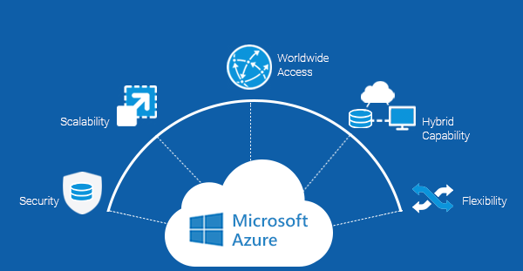

**Why do we need Microsoft Azure?**

**Storage.** Count on **Microsoft’s** global infrastructure to provide safe, highly accessible data storage. With massive scalability and an intelligent pricing structure that lets you store frequently accessed data a huge savings, building a safe and cost-effective storage plan **is** simple in **Microsoft Azure.**

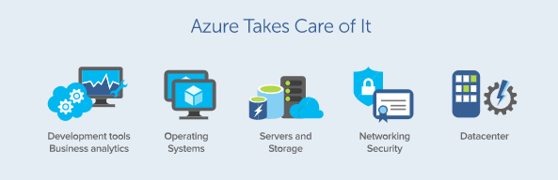

**Website:** [**https://azure.microsoft.com/**](https://azure.microsoft.com/)

**What is meant by Cloud Computing?**

**Cloud Computing** is the delivery of different services through the Internet. These resources include tools and applications like data storage, servers, databases, networking, and software. As long as an electronic devices has access to the web, it has access to the data and the software programs to run it.

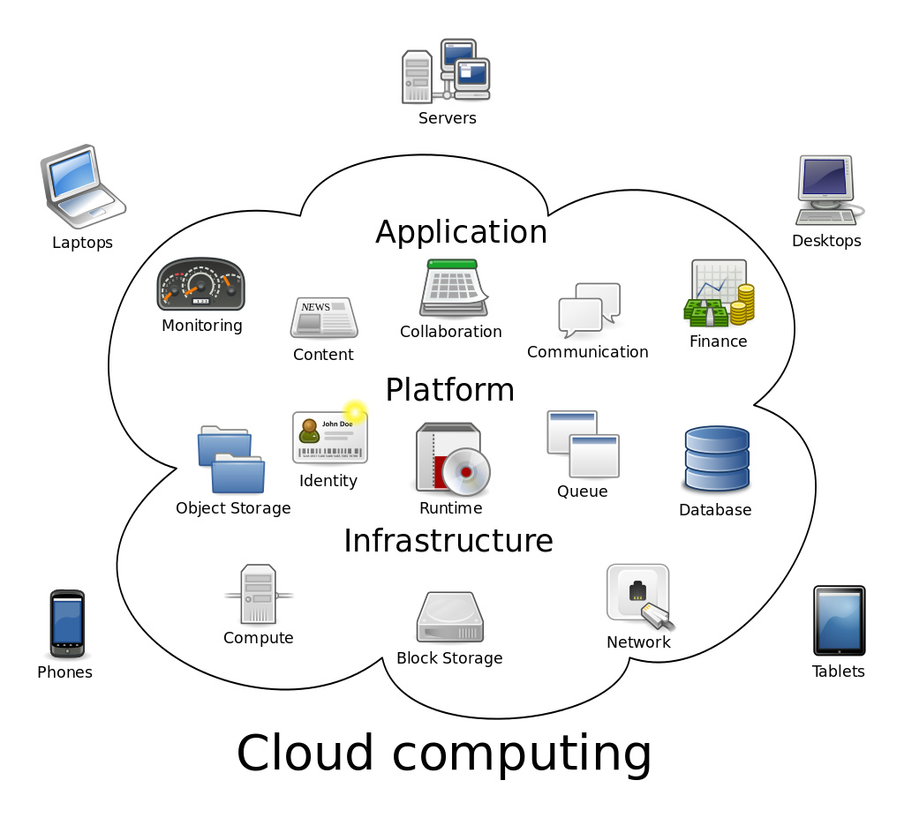

**What is meant by IaaS (Infrastructure as a Service)?**

It is an instant computing infrastructure, provisioned and managed over the internet. It helps you to avoid the expense and complexity of buying and managing your own physical servers and other Data Centre Infrastructure.

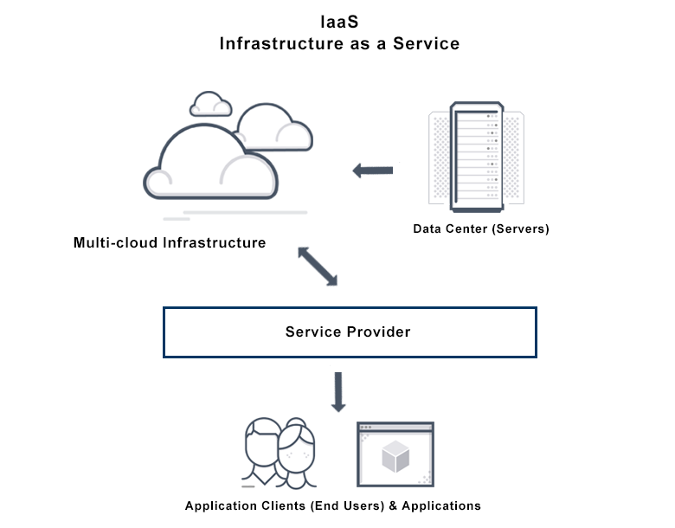

It is one of the four types of cloud services, along with Software as a Service (**SaaS)**, Platform as a Service (**PaaS)** and **serverless.**

**IaaS** quickly scales up and down with demand, letting you pay only for what you use. It helps you avoid the expense and complexity of buying and managing your own physical servers and datacentre infrastructure.

Each resource is offered as a separate service component and you only need to rent a particular one for as long as you need it. A **cloud computing service provider**, such as **Azure**, manages the infrastructure, while you purchase, install, configure and manage your own software – operating systems, middleware and applications.

Users can run any operating system or applications on the rented servers in geographic locations close to their end users. IaaS automatically scales, both up and down, depending on demand and provides guaranteed **Service-Level Agreement (SLA)** both in terms of uptime and performance. It eliminates the need to manually provision and manage physical servers in data centers.

**What is PaaS (Platform as a Service) ?**

Platform as a Service (PaaS) is a complete development and deployment environment in the cloud, with resources that enable you to deliver everything from simple cloud-based apps to sophisticated, cloud-enabled enterprise applications.

PaaS allows you to avoid the expense and complexity of buying and managing software licenses, the underlying application infrastructure and middleware, container orchestrators such as Kubernetes or the development tools and other resources.

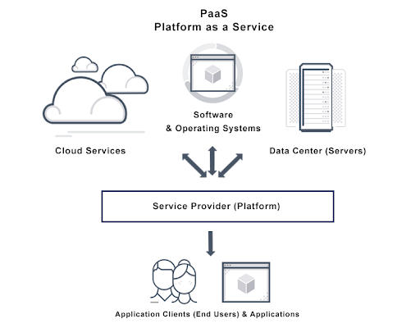

**What is meant by SaaS (Software as a Service):**

Software as a Service (or **SaaS**) is a way of delivering applications over the Internet – as a Service. Instead of installing and maintaining software you simply access via the Internet, freeing yourself from complex software and hardware management.

**Software as a Service (SaaS)** (also known as **subscribeware** or **rentware** ) is a software **licensing** and **delivery** model in which **software** is licensed on a **subscription** basis and is centrally **hosted.** It is sometimes referred to as “on-demand-software”, and was formerly referred to as “Software Plus Services” by **Microsoft.**

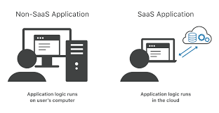

**Difference Between IaaS, PaaS And SaaS:**

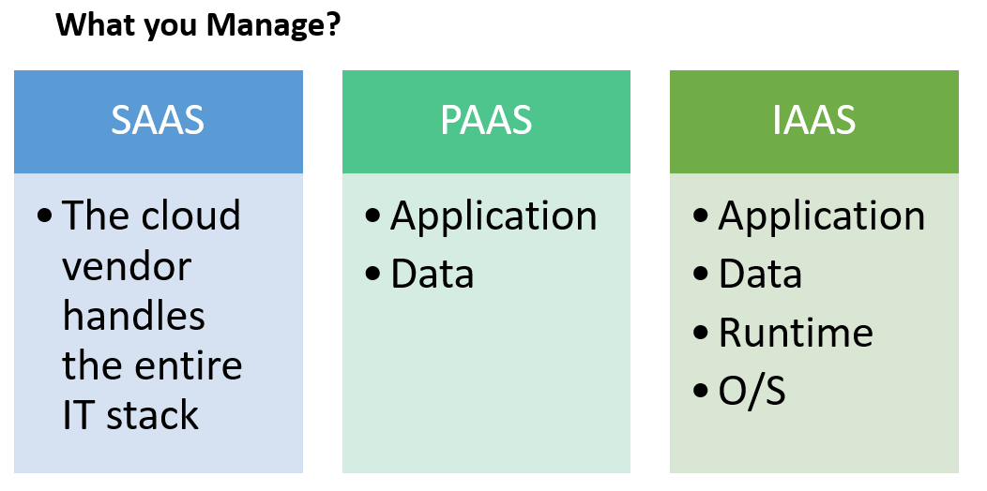

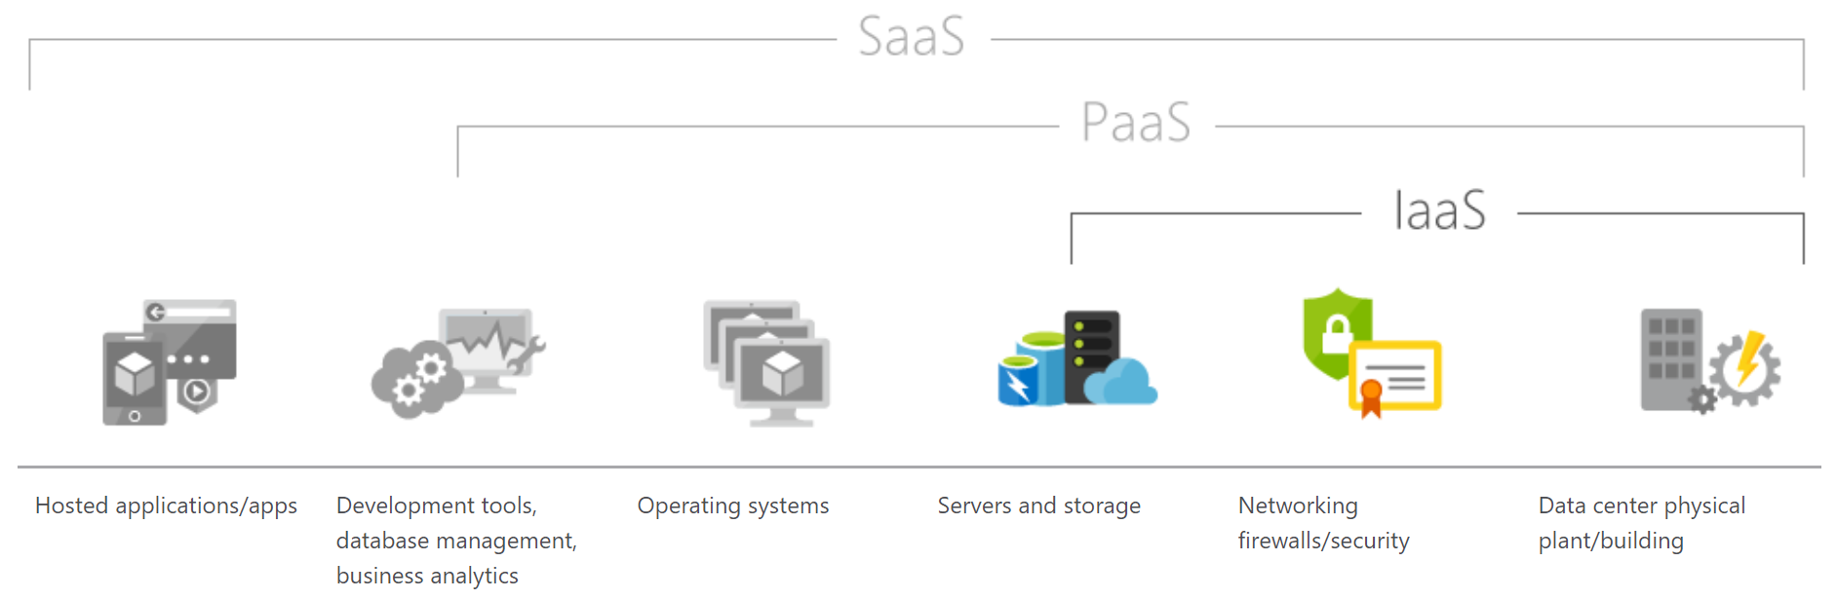

|  |  |
| --- | --- |
| **Platform Type** | **Common Examples** |
| **SaaS** | Google Workspace, Dropbox, Salesforce, Cisco WebEx, Concur, GoToMeeting |
| **PaaS** | AWS Elastic Beanstalk, Windows Azure, Heroku, Force.com, Google App Engine, Apache Stratos, OpenShift |
| **IaaS** | DigitalOcean, Linode, Rackspace, Amazon Web Services (AWS), Cisco Metapod, Microsoft Azure, Google Compute Engine (GCE) |

**Top Advantages of IAAS:**

**Scalability:**

IaaS quickly scales up and down-on-demand, letting you pay only for what you use. IaaS is the most flexible cloud computing model. For Instance, as soon as you decide to launch a new product or application, the necessary computing infrastructure can be ready within minutes or hours.

**Cost-efficient:**

It can be economic option for start-ups or enterprises testing new ideas because it eliminates the upfront expense of buying hardware outright and managing an on-premise data center. Furthermore, resources can be purchased as needed, letting you pay for only what you use. For Instance, IaaS is an effective model for experimental applications. Organizations can host and test the application using an IaaS Provider, then refine it or go in a different direction without having to take on the full cost and responsibility of purchasing and maintaining onsite data centers.